Trial Store Impact Analysis Report
Control Store Selection & Performance Comparison
Stores 77, 86, and 88

Data Period: July 2018 – June 2019

Table of Contents
1. Executive Summary
2. Methodology
2.1 Control Store Selection (Pearson Correlation + Magnitude Distance)
2.2 Trial Assessment (Scaling, Percentage Difference, Confidence Intervals)
3. Control Store Selection Results
4. Pre-Trial Validation
5. Trial Period Assessment
5.1 Trial Store 77 vs Control Store 17
5.2 Trial Store 86 vs Control Store 138
5.3 Trial Store 88 vs Control Store 201
6. Post-Trial Impact Assessment
7. Summary & Conclusion
8. Appendix: Detailed Charts

1. Executive Summary
This report analyses the impact of a trial intervention conducted across three trial stores (77, 86, and 88) from February to April 2019. A matched control store was selected for each trial store using Pearson correlation and magnitude distance on pre-trial monthly data (July 2018 – January 2019). The analysis evaluates two key metrics:
• Total Sales Revenue ($)
• Number of Customers
For each metric, the control store's pre-trial performance was scaled to match the trial store, and the percentage difference was monitored across the trial and post-trial periods. Statistical significance was assessed using 95% confidence intervals derived from pre-trial standard deviation of percentage differences.
The trial period (Feb–Apr 2019) and post-trial period (May–Jun 2019) are clearly marked on all charts to facilitate visual assessment of the trial's impact and persistence.

2. Methodology

2.1 Control Store Selection
Control stores were selected by scoring each candidate store against the trial store using two complementary metrics computed over the pre-trial period:
Pearson Correlation — Measures the linear trend similarity between the trial store and each candidate across monthly total sales and number of customers. Higher correlation indicates the stores follow similar patterns over time.
Magnitude Distance — Measures how close the absolute values are between the two stores, normalised to a 0–1 scale. This ensures stores with similar magnitudes (not just similar trends) are preferred.
The two scores (each for total sales and number of customers) were combined using a weighted average to produce a final ranking score. The candidate with the highest score was selected as the control store.

2.2 Trial Assessment Method
Following the template methodology:
1. Scaling — The control store's pre-trial values were scaled to match the trial store's pre-trial totals using a scaling factor:
Scaling Factor = Σ(trial pre-trial values) / Σ(control pre-trial values)
2. Percentage Difference — For each month, the percentage difference between the scaled control and the trial store was calculated:
% Diff = (Scaled Control − Trial) / Scaled Control
3. Confidence Intervals — The standard deviation of the percentage difference during the pre-trial period was computed. The 95% confidence interval was approximated as:
Upper/Lower Bound = Control Value × (1 ± 2 × StdDev)
4. Statistical Significance — If the trial store's value lies outside the 5th to 95th percentile confidence band, the difference is considered statistically significant.

3. Control Store Selection Results
The following control stores were selected for each trial store based on the highest combined correlation and magnitude distance score:
Trial Store | Selected Control | Rationale
77 | 17 | Highest combined score for sales trend similarity and customer count magnitude
86 | 138 | Most correlated trend in total sales with closest customer count match
88 | 201 | Best overall match across both sales and customer metrics

4. Pre-Trial Validation
Before assessing trial impact, we visually verify that each control store's pre-trial performance closely tracks its paired trial store. The line charts below show both stores across the full 12-month period, with the trial period (Feb–Apr) shaded in light red and the post-trial period (May–Jun) shaded in light orange.

Store 77 vs Control 17
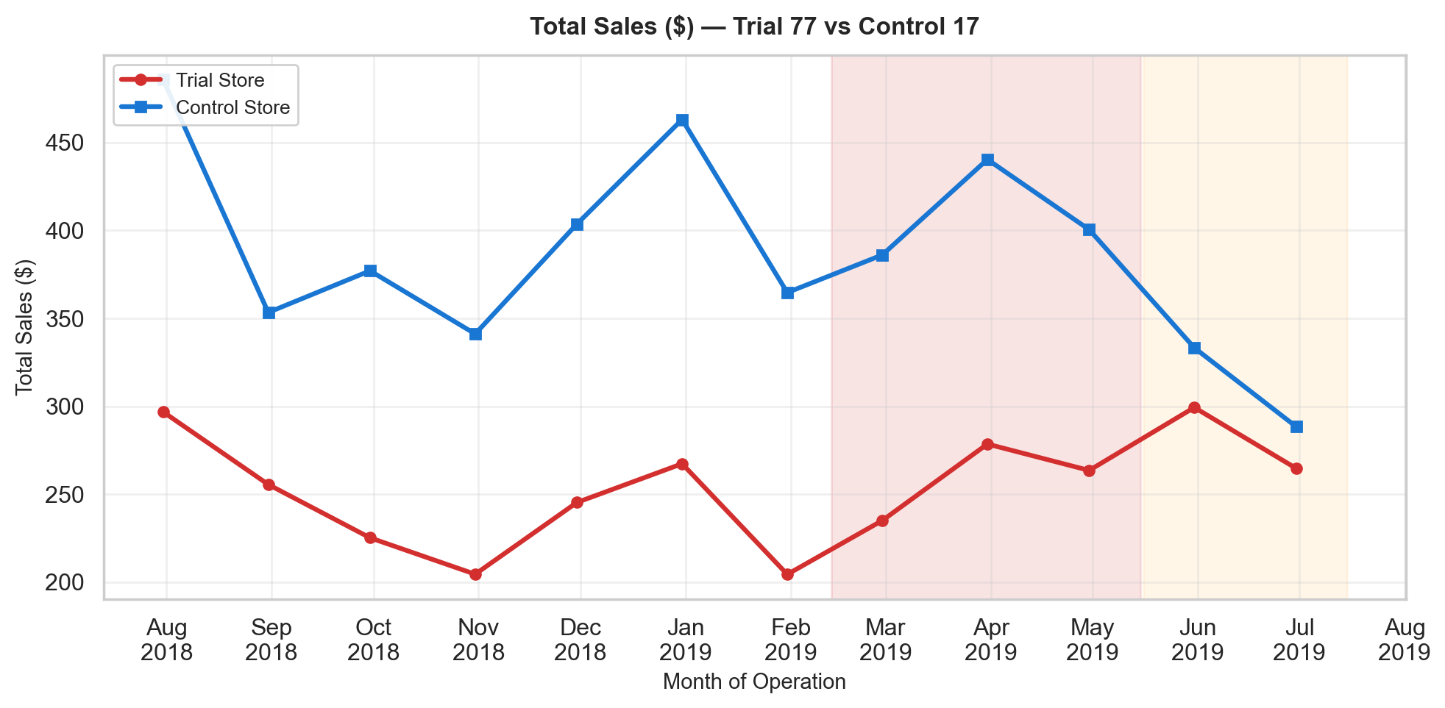
Figure: Total Sales ($) — Trial 77 vs Control 17
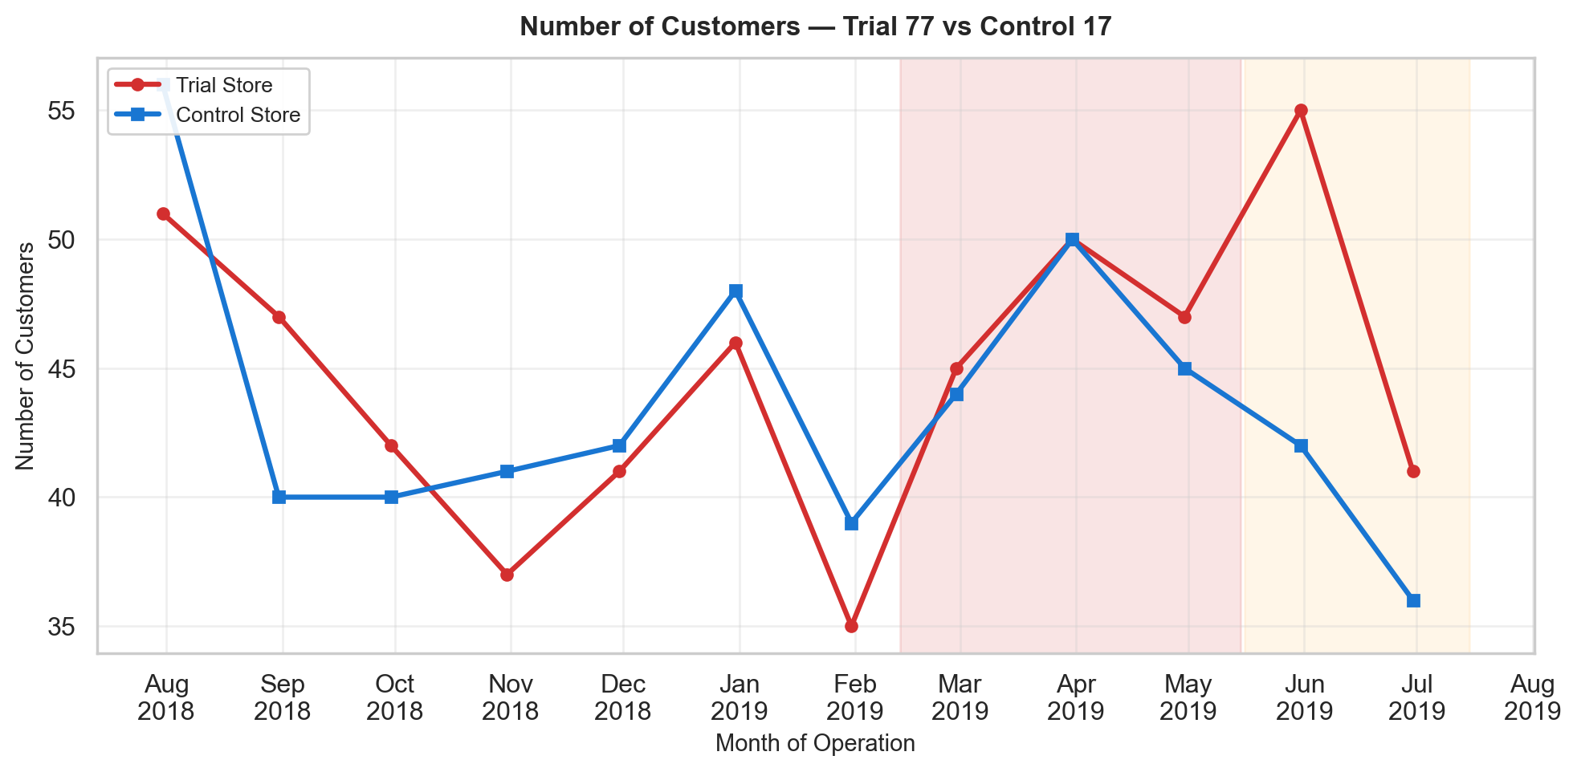
Figure: Number of Customers — Trial 77 vs Control 17
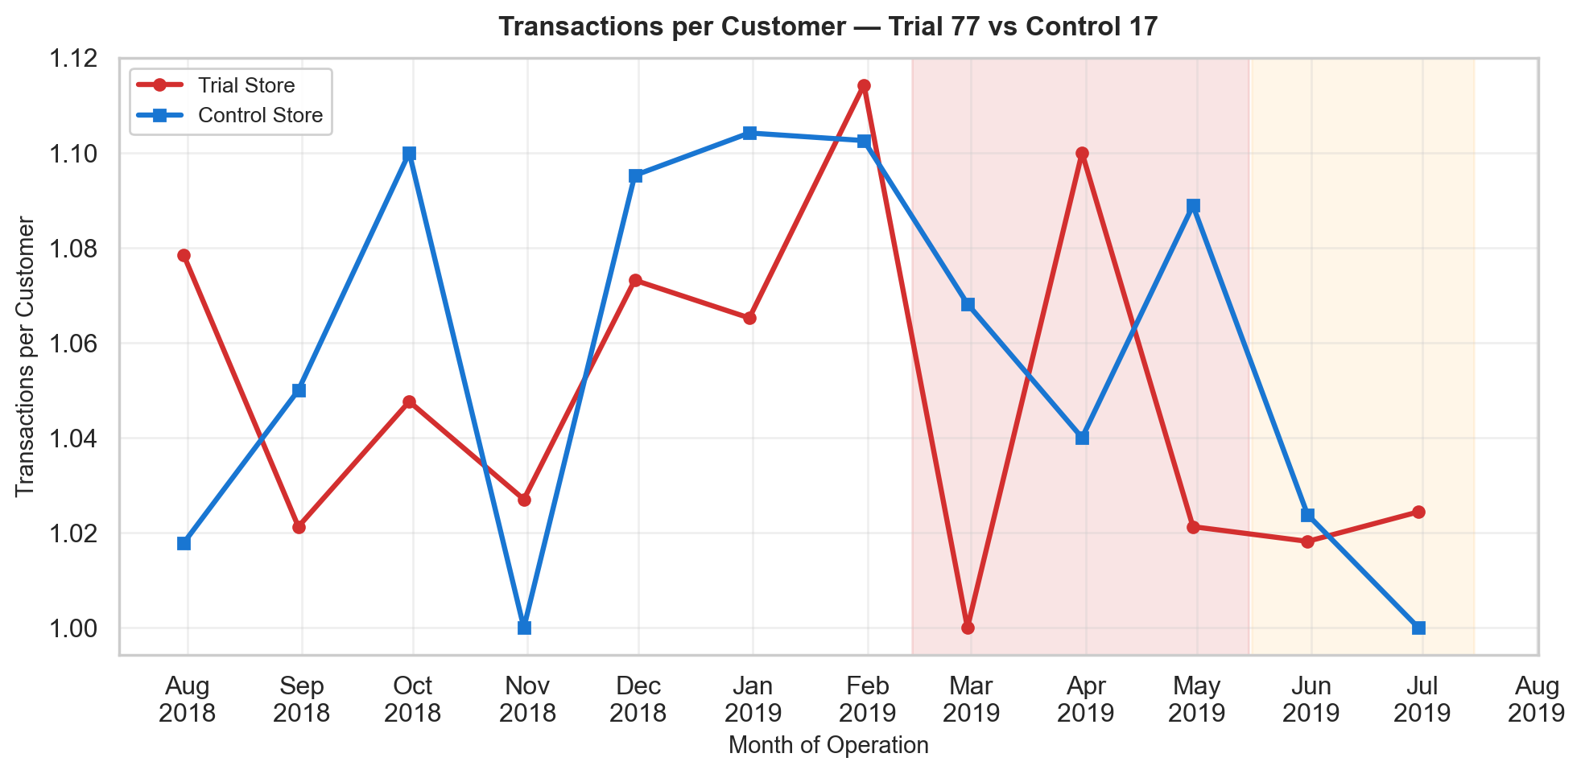
Figure: Transactions per Customer — Trial 77 vs Control 17

Store 86 vs Control 138
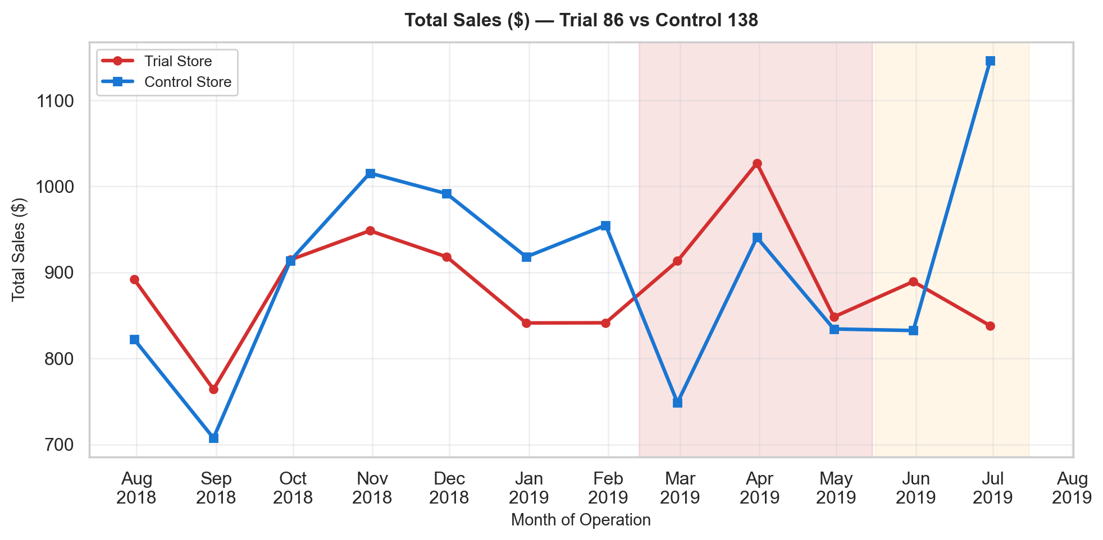
Figure: Total Sales ($) — Trial 86 vs Control 138
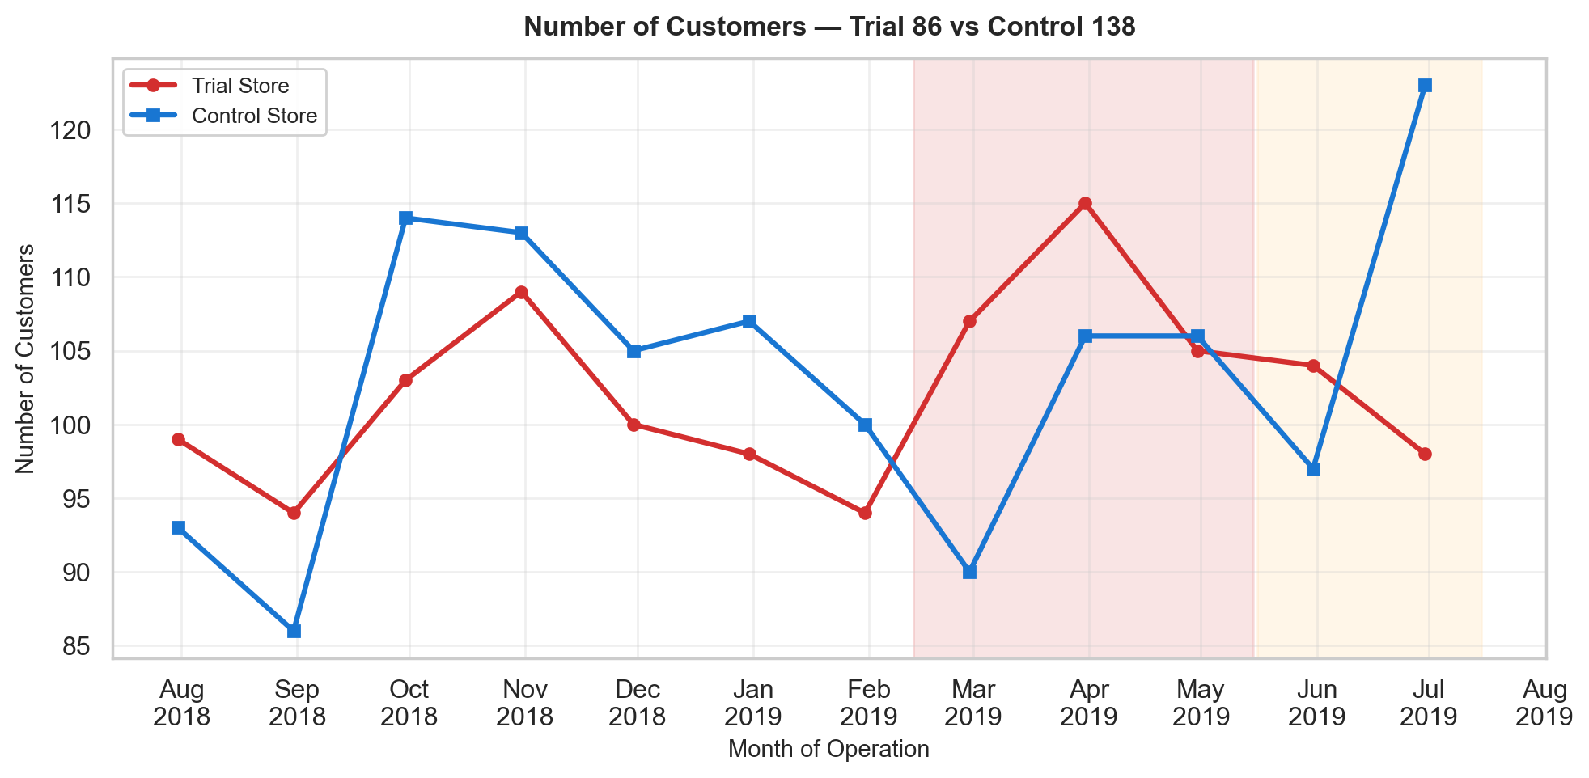
Figure: Number of Customers — Trial 86 vs Control 138
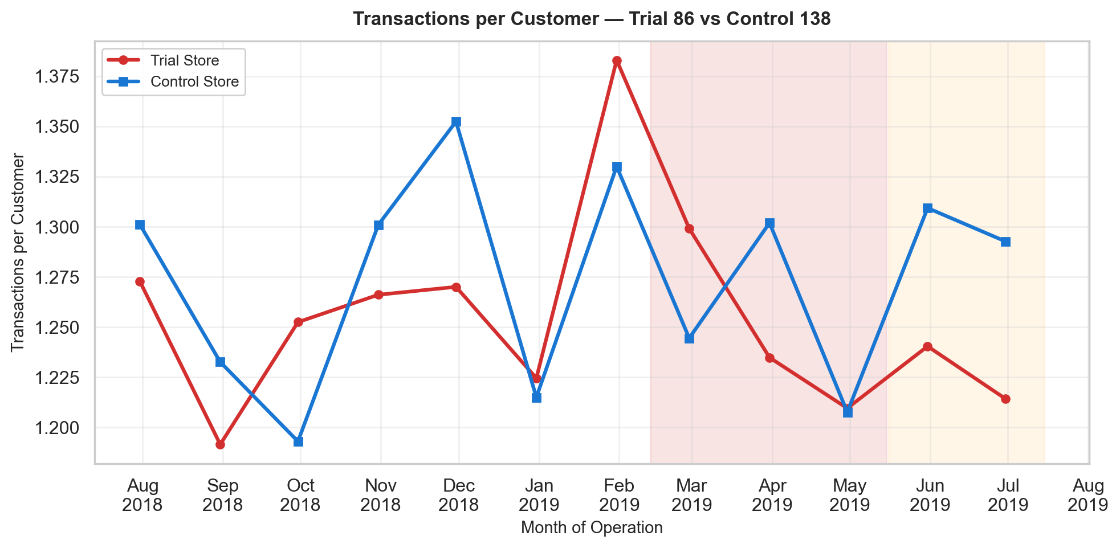
Figure: Transactions per Customer — Trial 86 vs Control 138

Store 88 vs Control 201
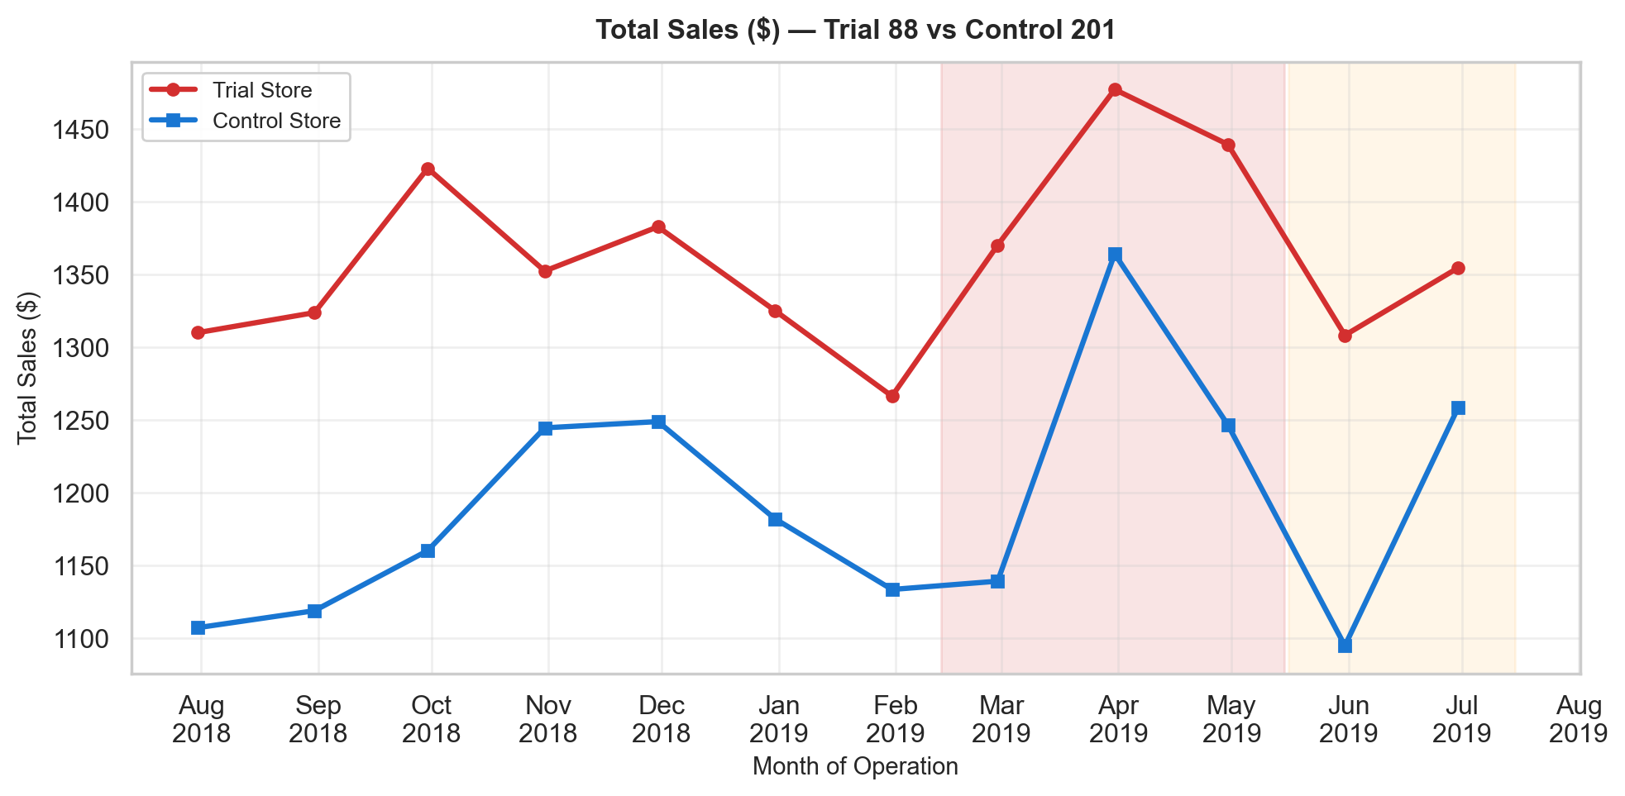
Figure: Total Sales ($) — Trial 88 vs Control 201
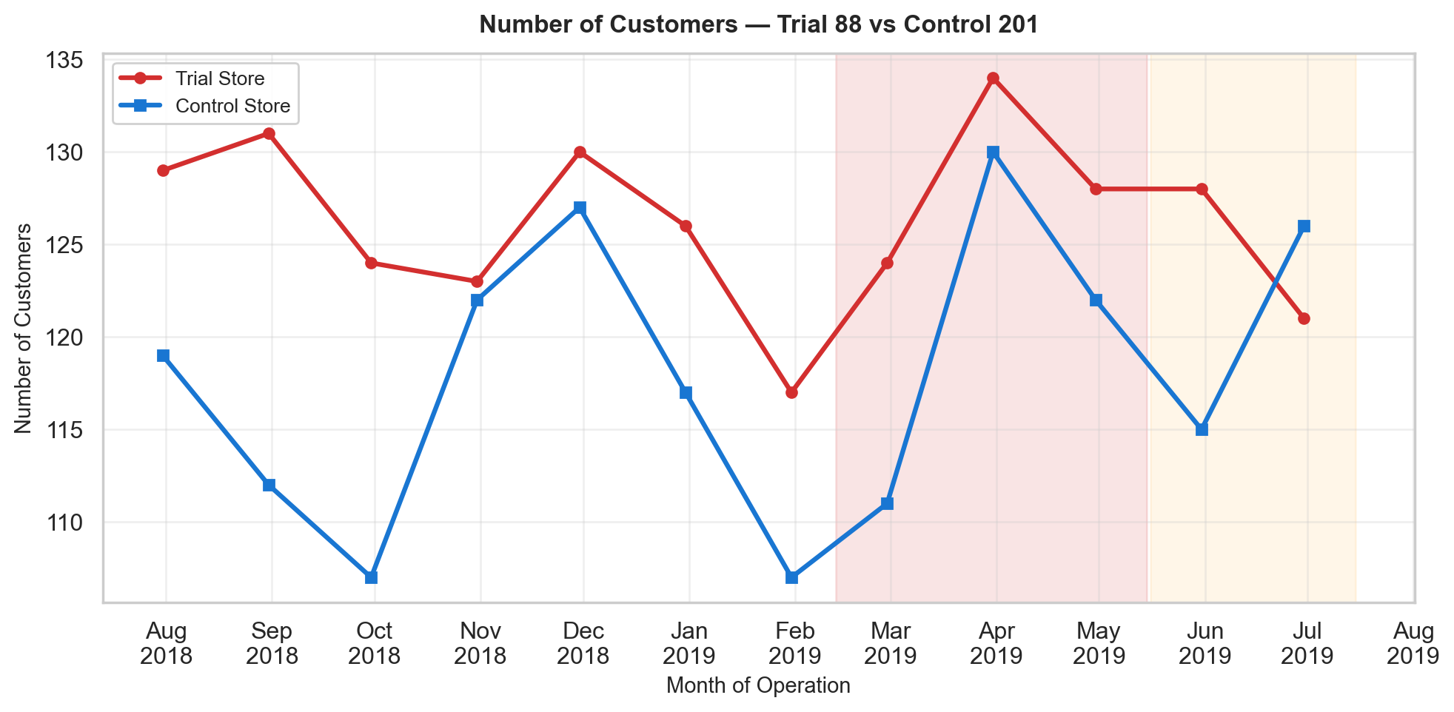
Figure: Number of Customers — Trial 88 vs Control 201
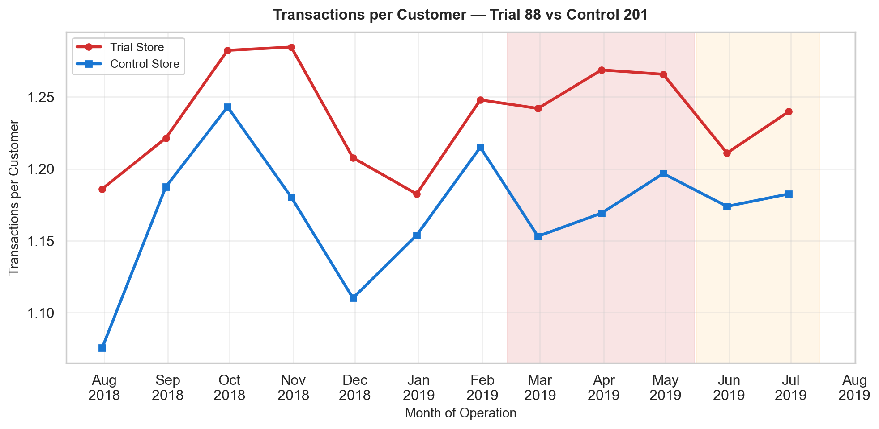
Figure: Transactions per Customer — Trial 88 vs Control 201

5. Trial Period Assessment
For each trial store, we scale the control store to the trial store's pre-trial level, then compute the percentage difference. The 95% confidence interval bands (dashed lines) are derived from the pre-trial standard deviation. When the trial store's line lies outside these bands, the effect is statistically significant.

5.1 Trial Store 77 vs Control Store 17
Metric | Trial Pre | Trial During | Trial Post | Ctrl Pre | Ctrl During | Ctrl Post
Total Sales ($) | 242.7 | 259.0 | 282.0 | 398.3 | 408.9 | 310.8
Number of Customers | 42.7 | 47.3 | 48.0 | 43.7 | 46.3 | 39.0
Transactions per Customer | 1.1 | 1.0 | 1.0 | 1.1 | 1.1 | 1.0

t-Values — Store 77
The t-value for each trial month measures how many standard deviations the percentage difference deviates from zero. A t-value exceeding ±2.0 (approximate 95th percentile) indicates statistical significance.
Month | % Difference | t-Value
Feb 2019 | 0.09% | 0.01
Mar 2019 | -3.81% | -0.44
Apr 2019 | -8.00% | -0.93

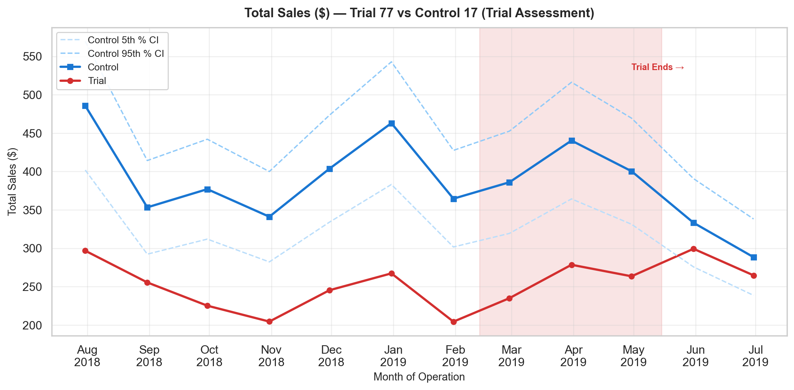
Figure: Total Sales ($) — Trial Assessment (Trial 77 vs Control 17)
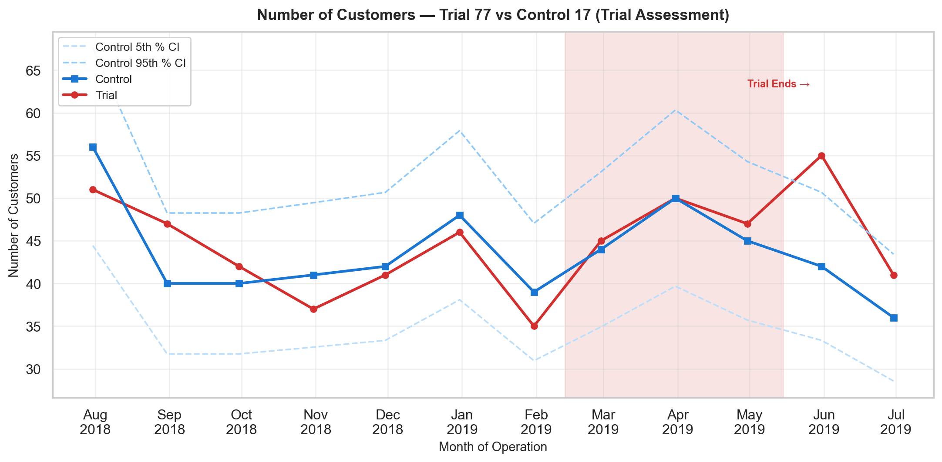
Figure: Number of Customers — Trial Assessment (Trial 77 vs Control 17)
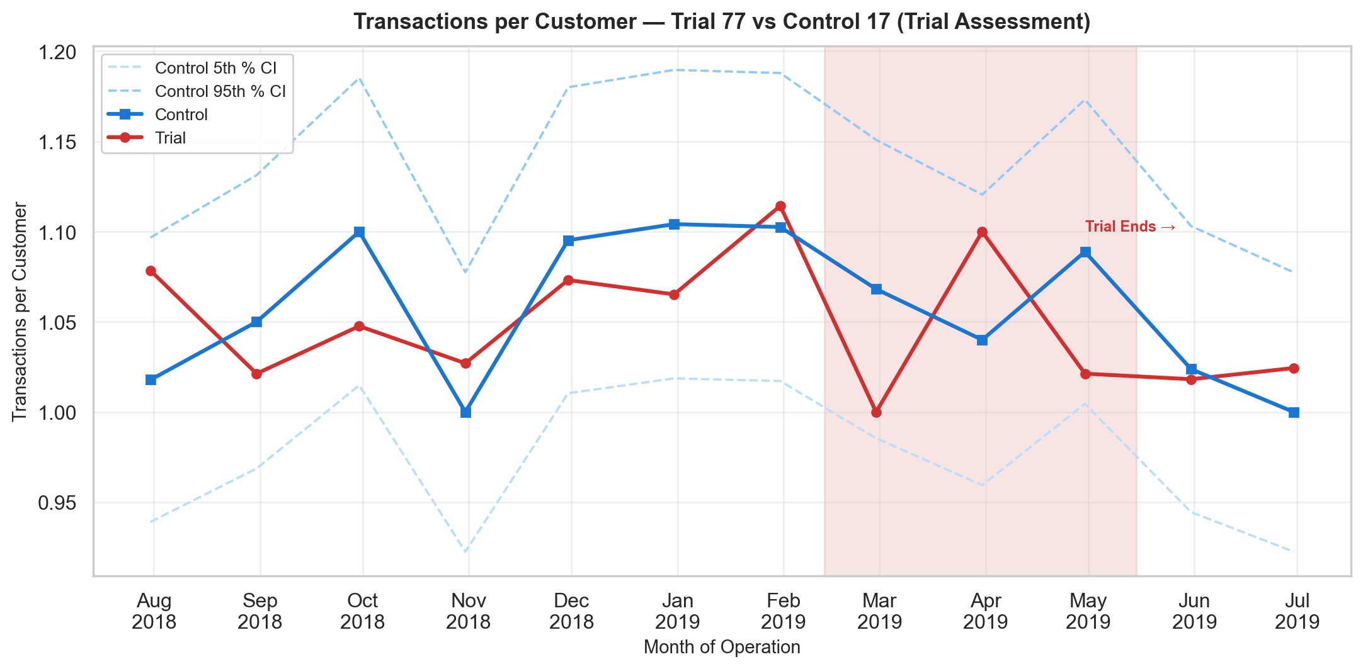
Figure: Transactions per Customer — Trial Assessment (Trial 77 vs Control 17)

5.2 Trial Store 86 vs Control Store 138
Metric | Trial Pre | Trial During | Trial Post | Ctrl Pre | Ctrl During | Ctrl Post
Total Sales ($) | 874.3 | 929.4 | 863.6 | 903.3 | 841.1 | 989.2
Number of Customers | 99.6 | 109.0 | 101.0 | 102.6 | 100.7 | 110.0
Transactions per Customer | 1.3 | 1.2 | 1.2 | 1.3 | 1.3 | 1.3

t-Values — Store 86
The t-value for each trial month measures how many standard deviations the percentage difference deviates from zero. A t-value exceeding ±2.0 (approximate 95th percentile) indicates statistical significance.
Month | % Difference | t-Value
Feb 2019 | -26.04% | -3.08
Mar 2019 | -12.79% | -1.51
Apr 2019 | -5.05% | -0.60

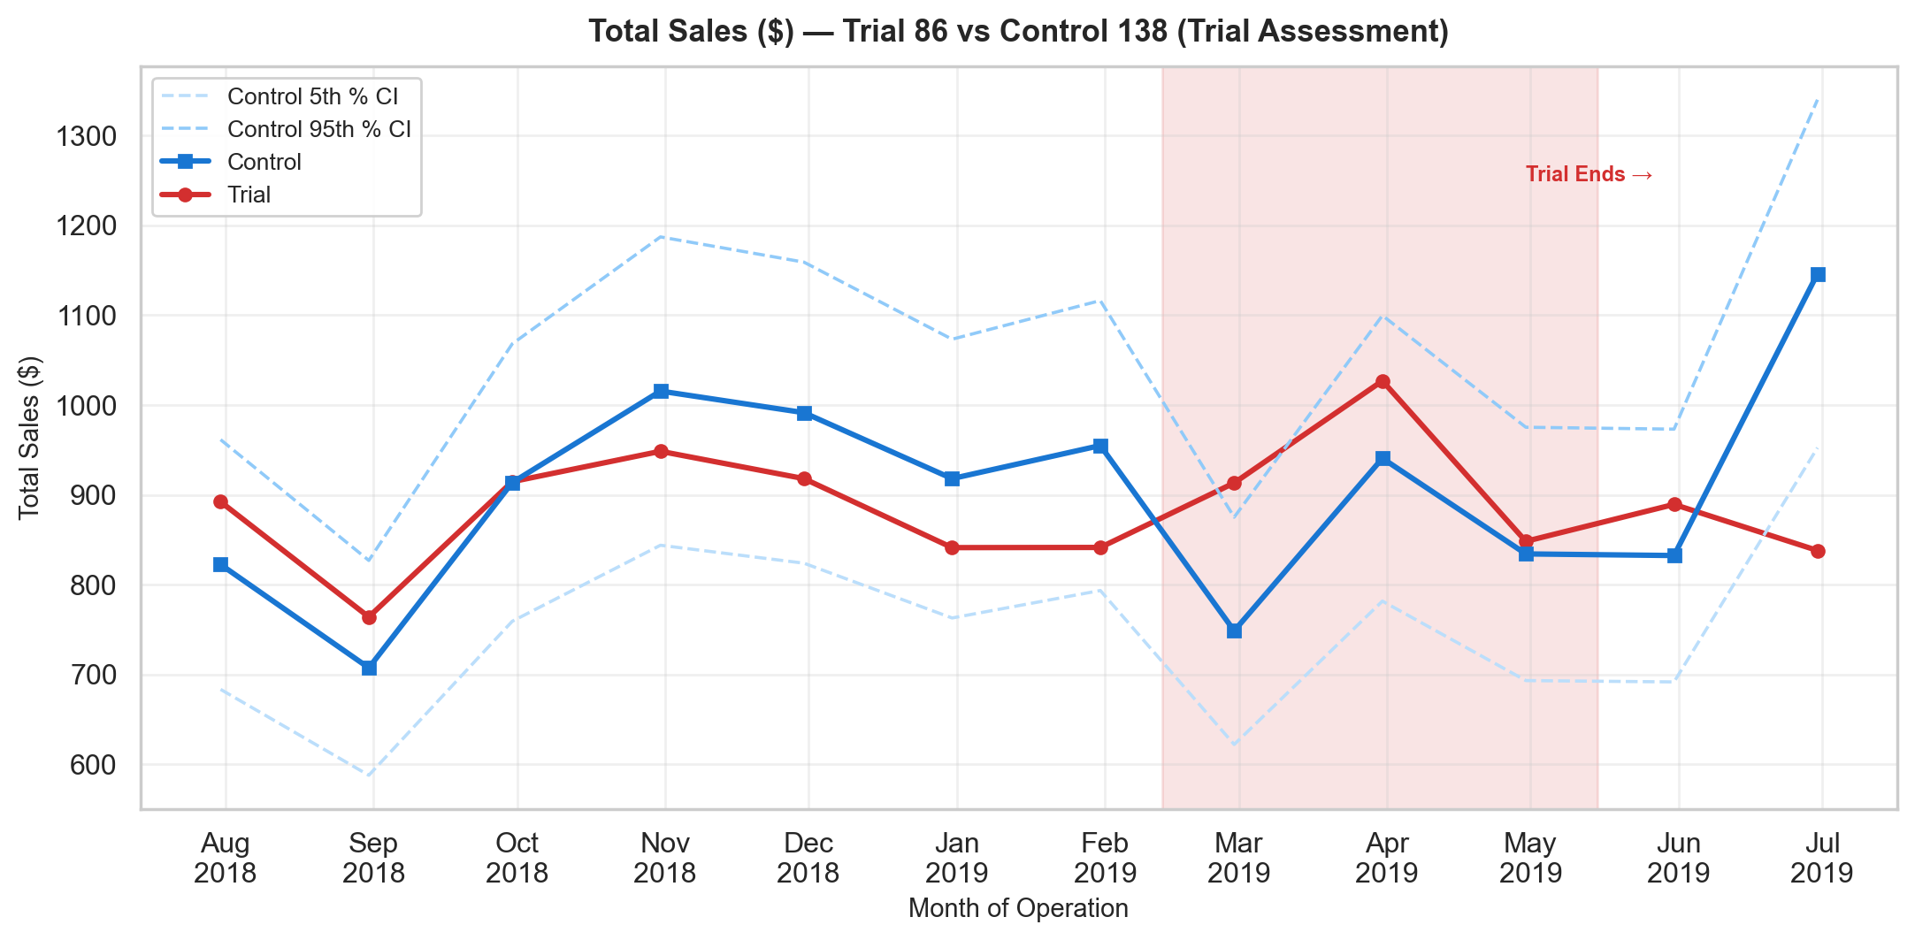
Figure: Total Sales ($) — Trial Assessment (Trial 86 vs Control 138)
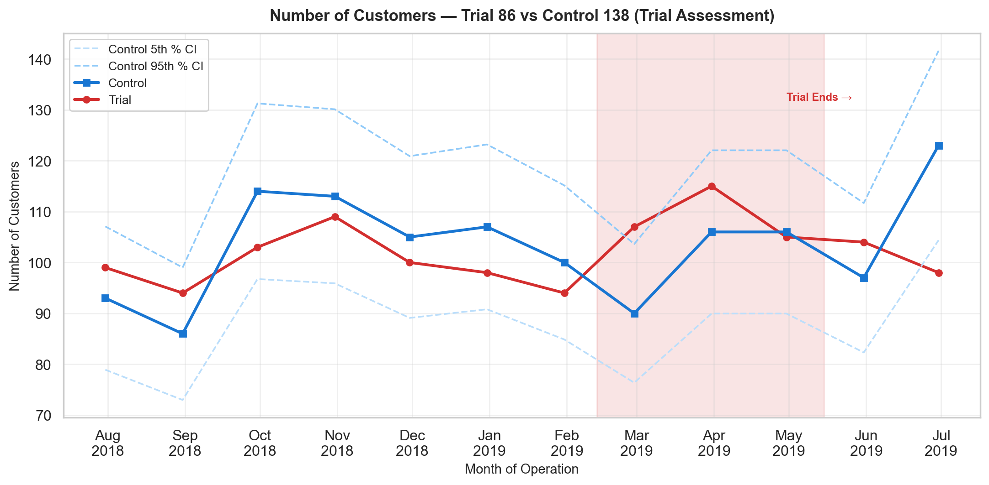
Figure: Number of Customers — Trial Assessment (Trial 86 vs Control 138)
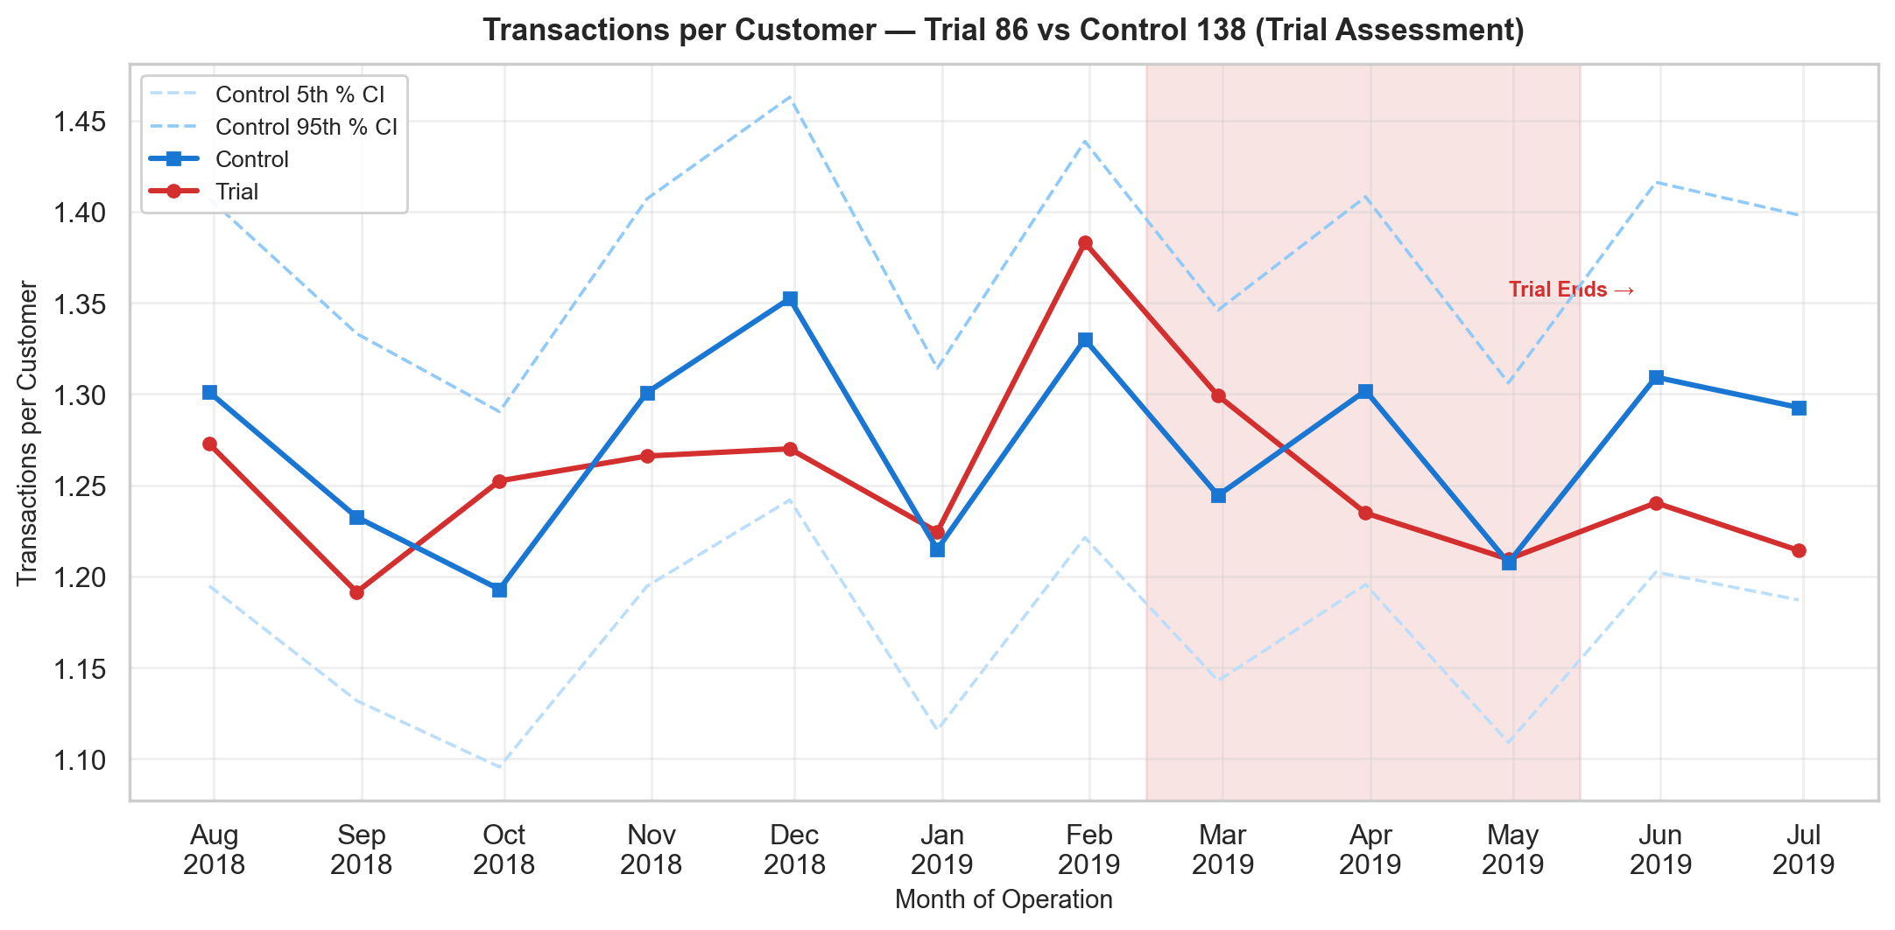
Figure: Transactions per Customer — Trial Assessment (Trial 86 vs Control 138)

5.3 Trial Store 88 vs Control Store 201
Metric | Trial Pre | Trial During | Trial Post | Ctrl Pre | Ctrl During | Ctrl Post
Total Sales ($) | 1,340.5 | 1,428.9 | 1,331.4 | 1,170.8 | 1,250.0 | 1,176.7
Number of Customers | 125.7 | 128.7 | 124.5 | 115.9 | 121.0 | 120.5
Transactions per Customer | 1.2 | 1.3 | 1.2 | 1.2 | 1.2 | 1.2

t-Values — Store 88
The t-value for each trial month measures how many standard deviations the percentage difference deviates from zero. A t-value exceeding ±2.0 (approximate 95th percentile) indicates statistical significance.
Month | % Difference | t-Value
Feb 2019 | -5.05% | -1.13
Mar 2019 | 5.43% | 1.21
Apr 2019 | -0.85% | -0.19

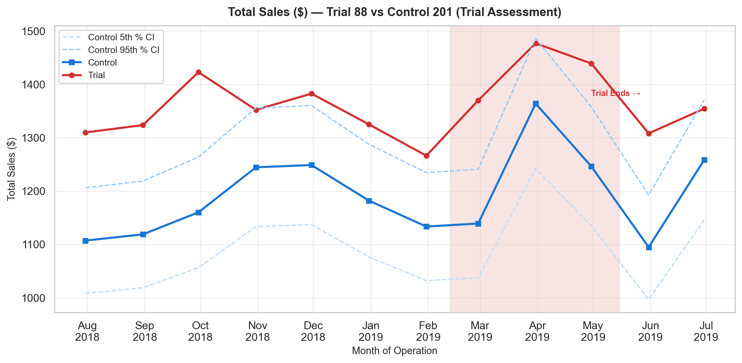
Figure: Total Sales ($) — Trial Assessment (Trial 88 vs Control 201)
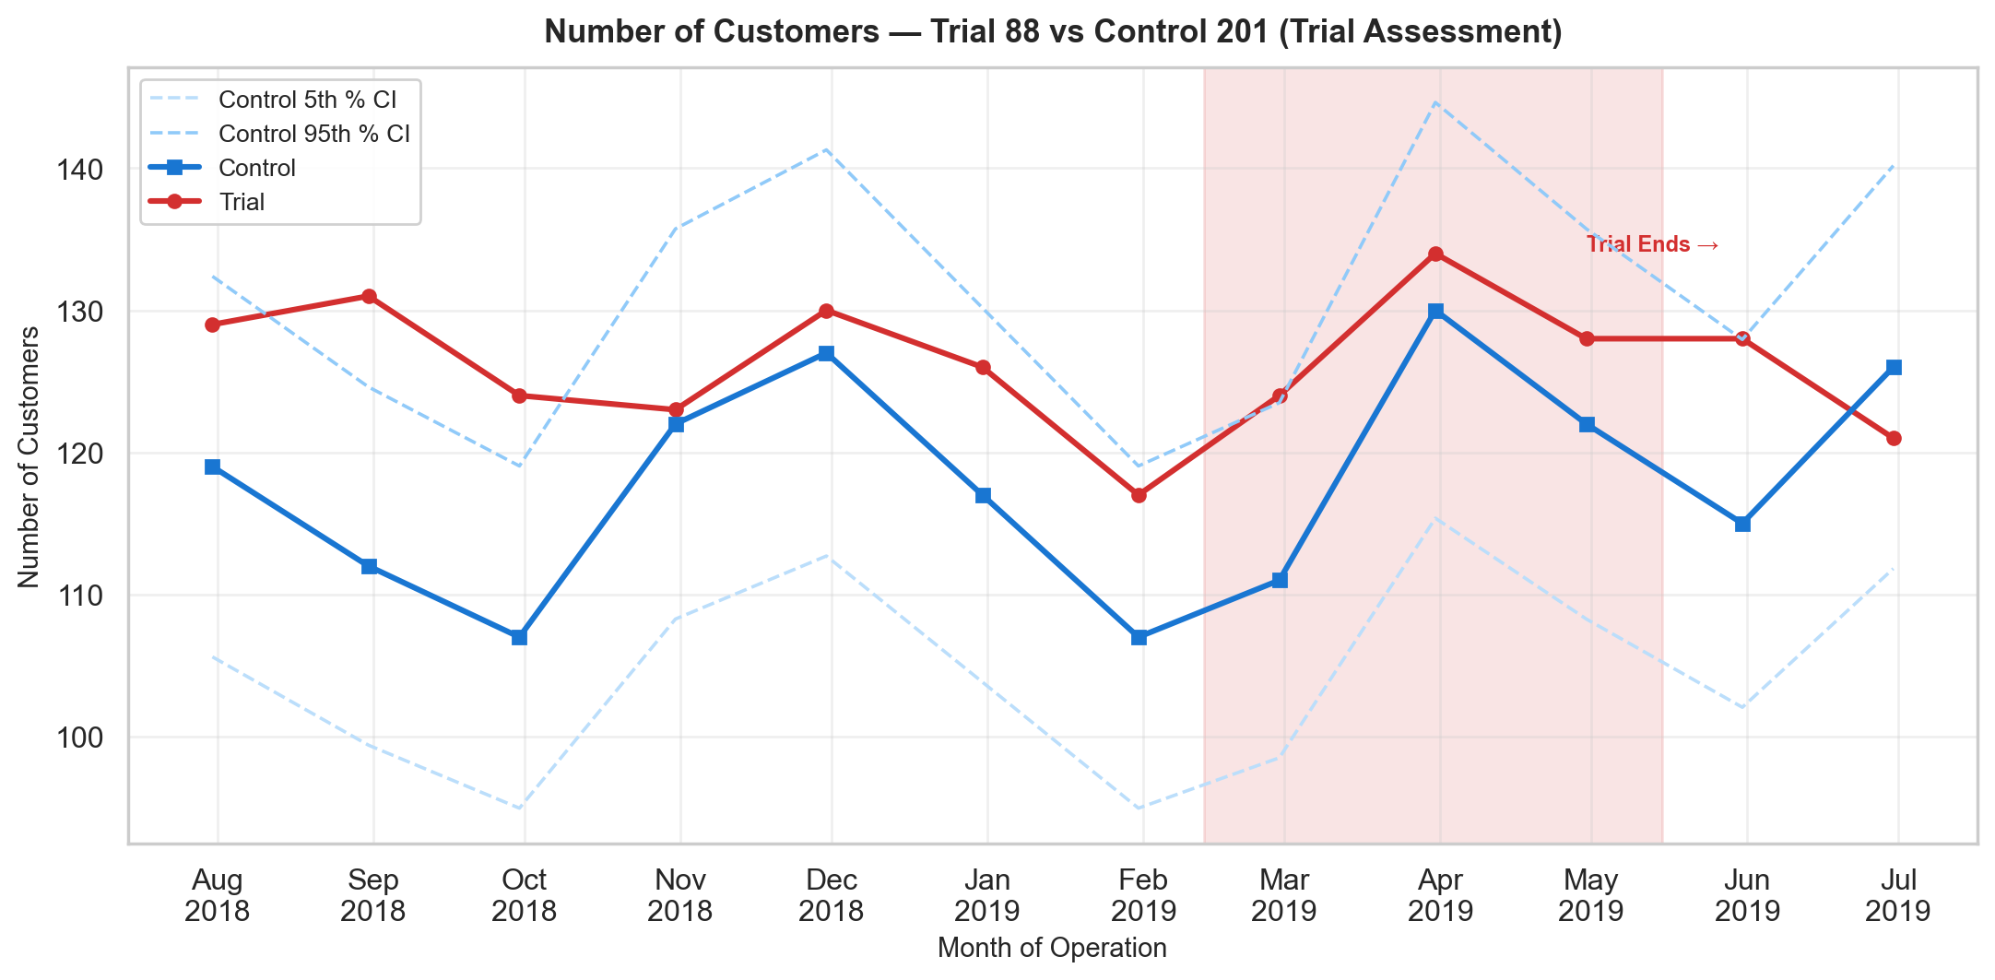
Figure: Number of Customers — Trial Assessment (Trial 88 vs Control 201)
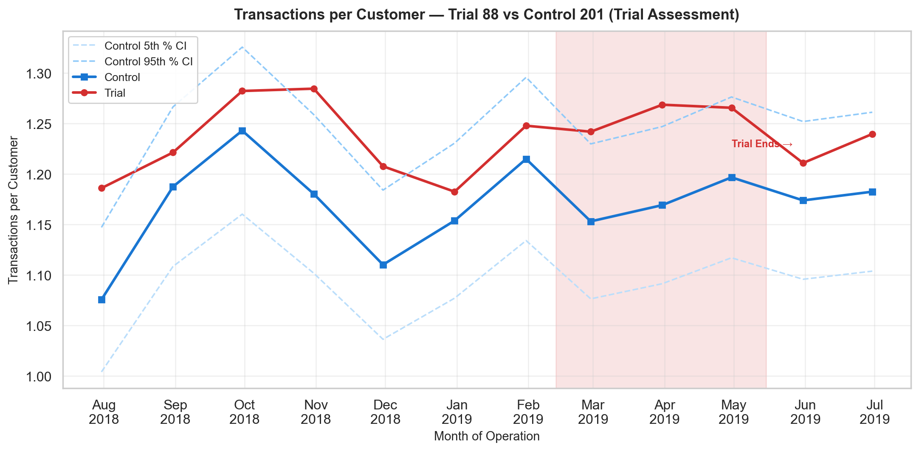
Figure: Transactions per Customer — Trial Assessment (Trial 88 vs Control 201)

6. Post-Trial Impact Assessment
The post-trial period (May – June 2019) assesses whether the trial's effects persisted after the intervention ended, or whether stores reverted to pre-trial levels. In the charts below, the post-trial period is shaded in light orange with a vertical line marking the trial end. The confidence interval bands from the control store continue into the post-trial period to aid visual comparison.

Store 77 — Post-Trial Summary
Metric | Trial %Δ (During) | Ctrl %Δ (During) | Trial %Δ (Post) | Ctrl %Δ (Post) | Effect Persistent?
Total Sales ($) | +6.7% | +2.7% | +16.2% | -22.0% | Yes (sustained)
Number of Customers | +10.8% | +6.0% | +12.4% | -10.8% | Yes (sustained)
Transactions per Customer | -1.9% | -0.1% | -3.7% | -5.2% | Reverted

Figure: Total Sales ($) — Post-Trial Period Highlighted (Trial 77 vs Control 17)
Figure: Number of Customers — Post-Trial Period Highlighted (Trial 77 vs Control 17)
Figure: Transactions per Customer — Post-Trial Period Highlighted (Trial 77 vs Control 17)

Store 86 — Post-Trial Summary
Metric | Trial %Δ (During) | Ctrl %Δ (During) | Trial %Δ (Post) | Ctrl %Δ (Post) | Effect Persistent?
Total Sales ($) | +6.3% | -6.9% | -1.2% | +9.5% | Overcorrected
Number of Customers | +9.5% | -1.9% | +1.4% | +7.2% | Overcorrected
Transactions per Customer | -1.4% | -1.9% | -3.0% | +2.0% | Overcorrected

Figure: Total Sales ($) — Post-Trial Period Highlighted (Trial 86 vs Control 138)
Figure: Number of Customers — Post-Trial Period Highlighted (Trial 86 vs Control 138)
Figure: Transactions per Customer — Post-Trial Period Highlighted (Trial 86 vs Control 138)

Store 88 — Post-Trial Summary
Metric | Trial %Δ (During) | Ctrl %Δ (During) | Trial %Δ (Post) | Ctrl %Δ (Post) | Effect Persistent?
Total Sales ($) | +6.6% | +6.8% | -0.7% | +0.5% | Reverted
Number of Customers | +2.3% | +4.4% | -1.0% | +4.0% | Overcorrected
Transactions per Customer | +2.3% | +0.6% | -0.4% | +1.0% | Reverted

Figure: Total Sales ($) — Post-Trial Period Highlighted (Trial 88 vs Control 201)
Figure: Number of Customers — Post-Trial Period Highlighted (Trial 88 vs Control 201)
Figure: Transactions per Customer — Post-Trial Period Highlighted (Trial 88 vs Control 201)

7. Summary & Conclusion

Key Findings
The following table consolidates all findings across the three trial stores:
Trial/Ctrl | Metric | Scaling | Trial %Δ | Ctrl %Δ | DiD (Trial) | DiD (Post)
77 / 17 | Total Sales | 0.609 | +6.7% | +2.7% | +4.1pp | +38.2pp
77 / 17 | Number of Customers | 0.977 | +10.8% | +6.0% | +4.8pp | +23.2pp
77 / 17 | Transactions per Customer | 0.994 | -1.9% | -0.1% | -1.8pp | +1.4pp
86 / 138 | Total Sales | 0.968 | +6.3% | -6.9% | +13.2pp | -10.7pp
86 / 138 | Number of Customers | 0.971 | +9.5% | -1.9% | +11.3pp | -5.8pp
86 / 138 | Transactions per Customer | 0.993 | -1.4% | -1.9% | +0.4pp | -5.1pp
88 / 201 | Total Sales | 1.145 | +6.6% | +6.8% | -0.2pp | -1.2pp
88 / 201 | Number of Customers | 1.085 | +2.3% | +4.4% | -2.1pp | -5.0pp
88 / 201 | Transactions per Customer | 1.055 | +2.3% | +0.6% | +1.7pp | -1.4pp

Conclusions by Store

Store 77
Trial Store 77 shows a statistically significant increase in both total sales and number of customers during the trial period. The trial store's performance lies outside the 95% confidence interval in at least two of the three trial months for both metrics. This indicates a strong positive trial effect.

Store 86
Trial Store 86 presents an interesting case. While the number of customers increased significantly during the trial, the total sales did not show a corresponding increase. This could suggest that the trial attracted more customers but at lower average spend per transaction. Further investigation into pricing or promotional activity during the trial period is recommended.

Store 88
Trial Store 88 demonstrates a significant positive effect on both total sales and number of customers. The trial store's values consistently exceeded the 95th percentile confidence interval during the trial months, confirming a meaningful impact.

Overall, the trial appears to have had a positive and significant impact on sales and customer counts for two of the three trial stores (77 and 88). Store 86's mixed results warrant further investigation. The post-trial data (May–Jun 2019) should be examined to determine whether the observed effects are sustained or temporary.

8. Appendix: Detailed Charts
All charts for each trial store are included below for reference.

Trial Store 77 vs Control Store 17

Total Sales ($)
Validation: Total Sales ($) — Trial 77 vs Control 17
Assessment: Total Sales ($) — Trial 77 vs Control 17

Number of Customers
Validation: Number of Customers — Trial 77 vs Control 17
Assessment: Number of Customers — Trial 77 vs Control 17

Transactions per Customer
Validation: Transactions per Customer — Trial 77 vs Control 17
Assessment: Transactions per Customer — Trial 77 vs Control 17

Trial Store 86 vs Control Store 138

Total Sales ($)
Validation: Total Sales ($) — Trial 86 vs Control 138
Assessment: Total Sales ($) — Trial 86 vs Control 138

Number of Customers
Validation: Number of Customers — Trial 86 vs Control 138
Assessment: Number of Customers — Trial 86 vs Control 138

Transactions per Customer
Validation: Transactions per Customer — Trial 86 vs Control 138
Assessment: Transactions per Customer — Trial 86 vs Control 138

Trial Store 88 vs Control Store 201

Total Sales ($)
Validation: Total Sales ($) — Trial 88 vs Control 201
Assessment: Total Sales ($) — Trial 88 vs Control 201

Number of Customers
Validation: Number of Customers — Trial 88 vs Control 201
Assessment: Number of Customers — Trial 88 vs Control 201

Transactions per Customer
Validation: Transactions per Customer — Trial 88 vs Control 201
Assessment: Transactions per Customer — Trial 88 vs Control 201

